**Books Management System(BMS)**

**Technical Design Specification**

**Version 0.1**

**DOCUMENT CONTROL**

**0.1 Version History**

| **Version** | **Author** | **Reviewed**  **By** | **Effective Date** | **Description of Changes** |
| --- | --- | --- | --- | --- |
| 0.1 | Lu Peng |  |  | 1st Release |
|  |  |  |  |  |
|  |  |  |  |  |
|  |  |  |  |  |
|  |  |  |  |  |

Table of Contents

1. UI 4

1.1 User Module 4

1.1.1 General Information 4

1.1.2 Login/Register/Update 5

1.2 Reader Module 8

1.2.1 General Information 8

1.2.2 add/update /delete/search/show detail 9

1.3 Book Module 14

1.3.1 General Information 14

1.3.2 add/update /delete/search/show detail 15

1.4 Borrow &Return Module 19

1.4.1 General Information 19

1.4.2 Add /return & cancel/search/show detail 20

2. Database 25

2.1 Database tables 25

2.1.1 tb_user(table1-5) 25

2.1.2 tb_reader(table1-6) 25

2.1.3 tb_book(table1-7) 25

2.1.4 tb_borrowItem(table1-8,-9) 25

2.2 Entity Relationship 26

# UI

## User Module

### General Information

|  |  |
| --- | --- |
| **Job Description** | Create user login module to let user login the BMS  update user password |
| **Job Type** | MVC Web |
| **Operation** | Login/Register/Update |
| **Job Details** | User login  New user register  Old user update password |

### Login/Register/Update

1. **Login**

System function is only permit login’s user. For new you can register firstly than to login system.

At first, you need entry system through URL, you will arrive home page. You can through Login linking to find login page. (chart 1-1,1-2)

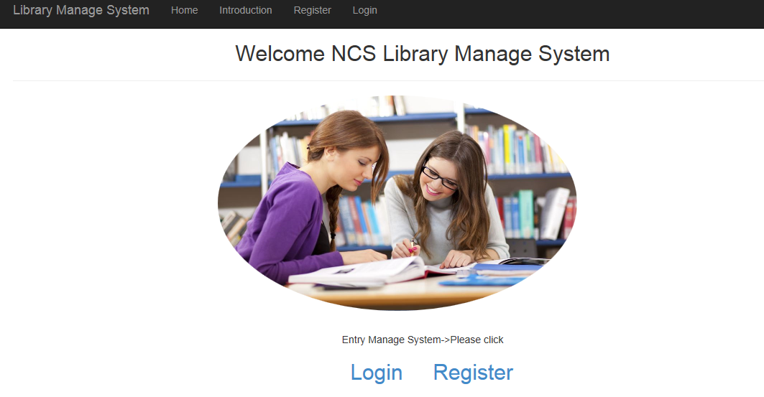

Chart 1-1

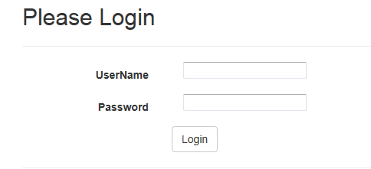

Chart 1-2

1. **Register**

You can through register linking to find register page. (Chart 1-3)

The field description as (Table1-1)

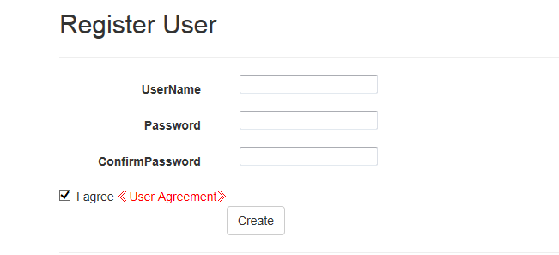

Chart 1-3

|  |  |  |  |  |  |  |  |
| --- | --- | --- | --- | --- | --- | --- | --- |
| **SN** | **Display Field Name** | **Description** | **Display Format** | **Mandatory** | **Default Value** | **Min Length** | **Max Length** |
| 1 | username | User login name | Text | No | NA | NA | NA |
| 2 | password | User login password | Text | No | NA | 6 | 20 |

Table1-1

1. **Update**

After entry system, you can through left navigation find modify password linking to modify password or through click your user name to modify password (chart1-4,1-5,1-6)

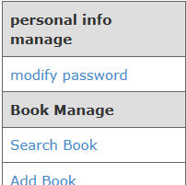

Chart 1-4



Chart1-5

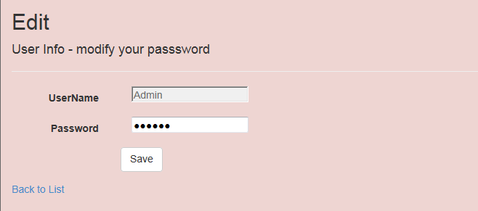

Chart 1-6

## 1.2 Reader Module

### 1.2.1 General Information

|  |  |
| --- | --- |
| **Job Description** | Create reader info module to store data to database, you also can modify reader info and delete current reader and search reader that you want to find and show reader detail info . |
| **Job Type** | MVC Web |
| **Operation** | add/update /delete/search/show detail |
| **Job Details** | New add reader  Old reader to update reader info  Delete reader  Search reader  Show detail reader info |

* + 1. **add/update /delete/search/show detail**

1. **add**

You can through left navigation find add reader linking to add reader info. (chart 2-1)

The field description as (Table1-1)

* Reader name, balance, available amount is required
* Balance is reader’s account balance if balance is zero that this reader will not allow to borrow.
* Available amount that is reader can borrow book’s quantity.

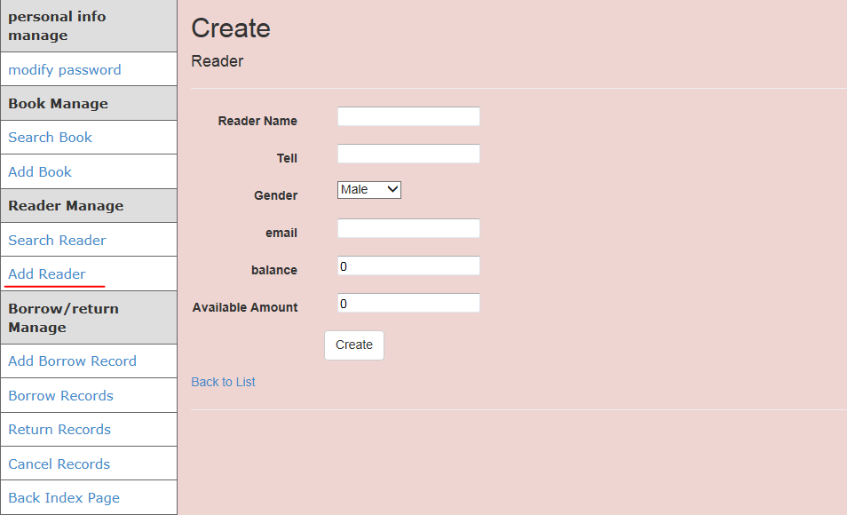

Chart 2-1

|  |  |  |  |  |  |  |  |
| --- | --- | --- | --- | --- | --- | --- | --- |
| **SN** | **Display Field Name** | **Description** | **Display Format** | **Mandatory** | **Default Value** | **Min Length** | **Max Length** |
| 1 | Reader Name | Borrower’s Name | Text | No | NA | NA | NA |
| 2 | Tell | Borrower’s mobile phone number | Text | No | NA | NA | NA |
| 3 | Gender | Borrower’s gender | Dropdown list | Yes | Male | NA | NA |
| 4 | Email | Borrower’ email | Text | No | NA | NA | NA |
| 5 | Balance | Borrower’s balance | Text | Yes | 0 | NA | NA |
| 6 | Available amount | Borrower’s Available amount | Text | Yes | 0 | NA | NA |
| 7 | Create name | The name of created Borrower | Text | Yes | Login user | NA | NA |
| 8 | Create Time | The time of created Borrower | Text | Yes | System time | NA | NA |

Table1-2

1. **Search**

You can through left navigation find search reader linking to search reader. (chart 2-2)

* You can input reader name to search for you want to find.

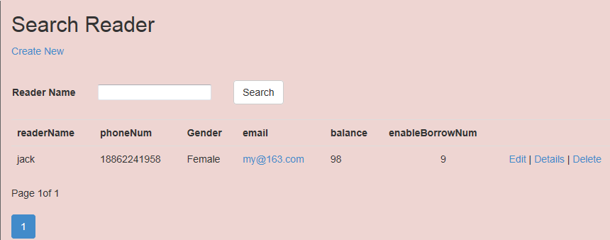

Chart 2-2

1. **Update**

After you entry search reader page, you can through right edit operation to update reader info. (chart2-3)

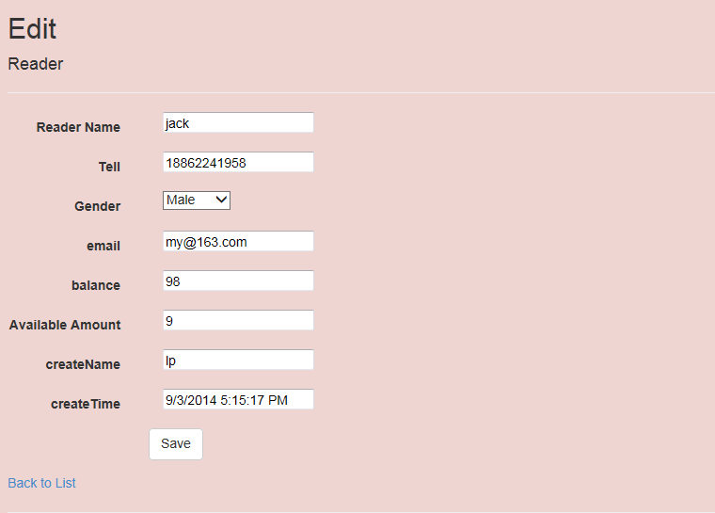Chart 2-3

1. **show detail**

After you entry search reader page, you can through right details operation to show reader details info. (chart2-4)

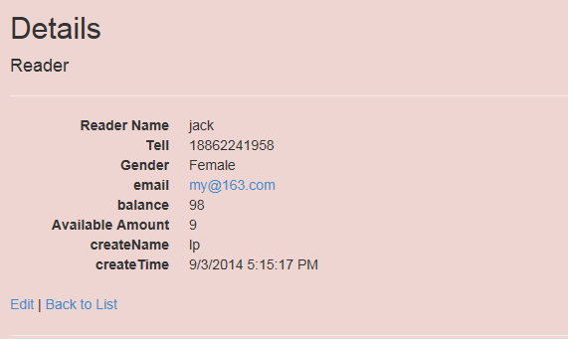

Chart2-4

1. **delete**

After you entry search reader page, you can through right delete operation to delete this reader. (chart 2-5)

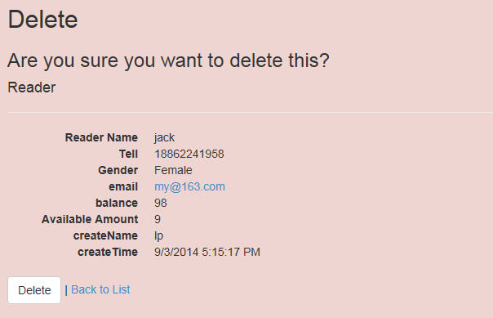

Chart2-5

## 1.3 Book Module

### 1.3.1 General Information

|  |  |
| --- | --- |
| **Job Description** | Create book info module to store data to database, you also can modify book info and delete current book and search book that you want to find and show book detail info. |
| **Job Type** | MVC Web |
| **Operation** | add/update /delete/search/show detail |
| **Job Details** | New add book  Old book to update book info  Delete book  Search book  Show detail book info |

* + 1. **add/update /delete/search/show detail**

1. **add**

You can through left navigation find add reader linking to add book info. (chart 3-1)

The field description as (Table1-3)

* book name, amount is required
* Field of amount is book amount if amount is zero that this book will not allow to borrow.

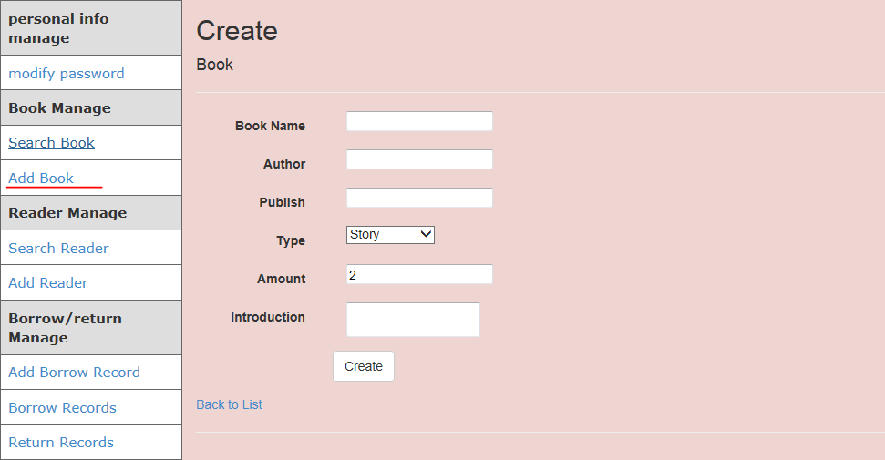

Chart 3-1

|  |  |  |  |  |  |  |  |
| --- | --- | --- | --- | --- | --- | --- | --- |
| **SN** | **Display Field Name** | **Description** | **Display Format** | **Mandatory** | **Default Value** | **Min Length** | **Max Length** |
| 1 | Book name | Book’s name | Text | Yes | NA | NA | NA |
| 2 | Author | Book’s author | Text | No | NA | NA | NA |
| 3 | Publish | Book’s publish | Text | No | NA | NA | NA |
| 4 | Type | Book’s type | Dropdown list | Yes | Story | NA | NA |
| 5 | Amount | Book’s amount | Text | Yes | 2 | NA | NA |
| 6 | Introduction | Book’s introduction | Text | No | NA | NA | NA |
| 7 | Create name | The name of created Borrower | Text | Yes | Login name | NA | NA |
| 8 | Create Time | The time of created Borrower | Text | Yes | System time | NA | NA |
| 9 | CurrAmount | Book’s current amount | Text | Yes | 2 | NA | NA |

Table1-3

1. **Search**

You can through left navigation find search book linking to search book. (chart 3-2)

* You can input book name or author name to search for you want to find.
* After you search, you can through table of column title to sort.

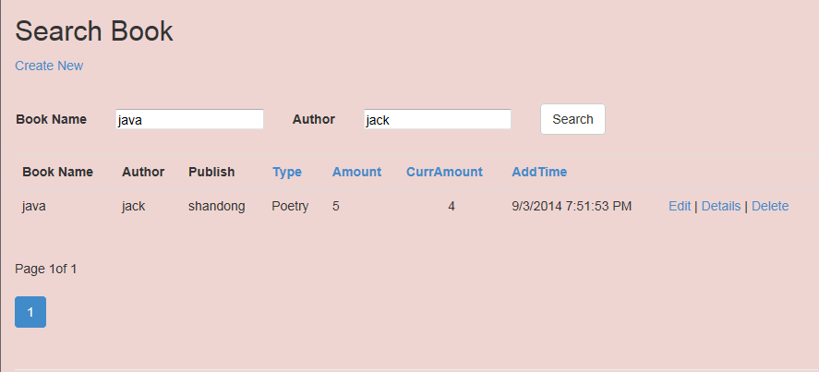

Chart 3-2

1. **Update**

After you entry search book page, you can through right edit operation to update book info. (chart 3-3)

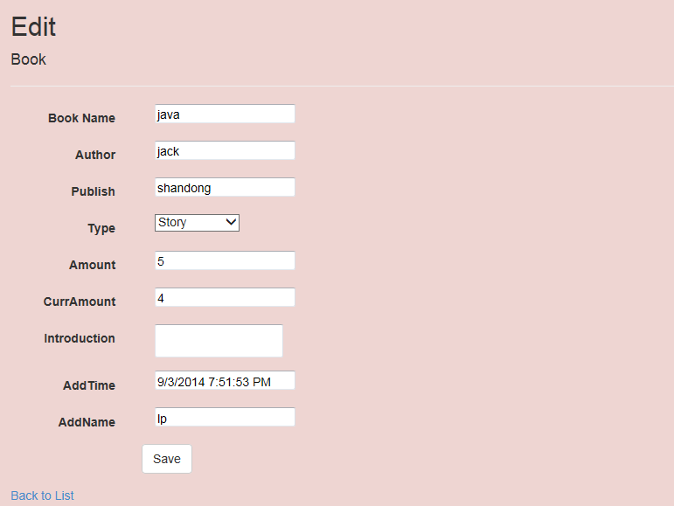

Chart3-3

1. **Show details**

After you entry search book page, you can through right details operation to show detail book info. (chart3-4)

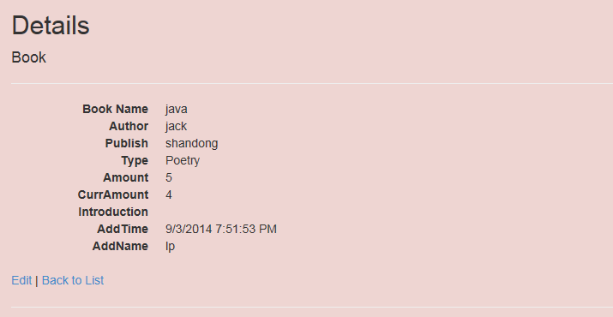

Chart3-4

1. **Delete**

After you entry search book page, you can through right delete operation to delete this book info. (chart3-5)

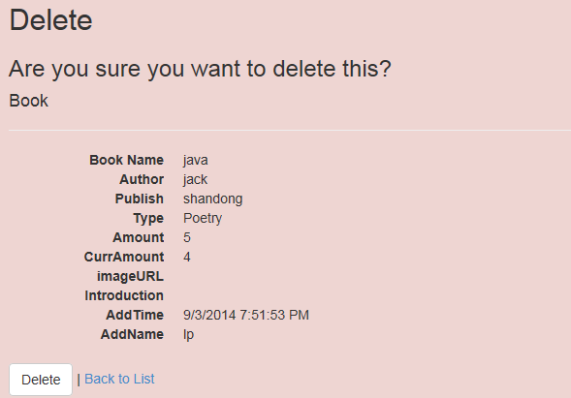

chart3-5

## 1.4 Borrow &Return Module

### 1.4.1 General Information

|  |  |
| --- | --- |
| **Job Description** | Create Borrow &Return record module to store data to database, you also can through book name and reader name to borrow book.  After borrow book, you can use right operation to return or cancel this borrow record. |
| **Job Type** | MVC Web |
| **Operation** | Add /return & cancel/search/show detail |
| **Job Details** | Add borrow book record  Return & cancel book  According to status to search book record  Show detail book info |

**1.4.2 Add /return & cancel/search/show detail**

1. **Add & search**

You can through left navigation find add borrow record linking to create borrow record. (chart 4-1) The field description as (Table1-4)

* book name, reader name is required
* You can through dropdown list to choose book name and reader name to finish borrow operation.
* You can use left borrow, return, cancel to search related records.

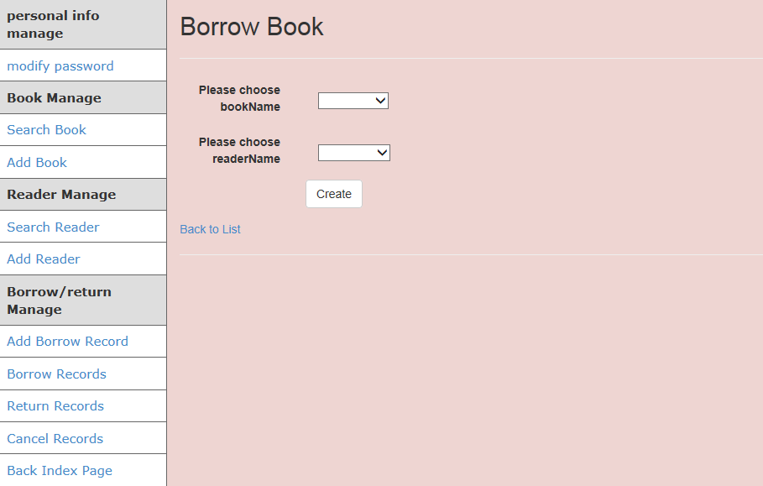

Chart 4-1

|  |  |  |  |  |  |  |  |
| --- | --- | --- | --- | --- | --- | --- | --- |
| **SN** | **Display Field Name** | **Description** | **Display Format** | **Mandatory** | **Default Value** | **Min Length** | **Max Length** |
| 1 | Book name | Book’s name | Dropdown list | Yes | NA | NA | NA |
| 2 | Reader name | Borrower’s name | Dropdown list | Yes | NA | NA | NA |
| 3 | Status | Borrow book status | Text | Yes | Borrow | NA | NA |
| 4 | Borrow time | Borrow book time | text | Yes | Borrow book current time | NA | NA |
| 5 | Preset return time | Preset return time | text | Yes | More than the three months on base of Borrow book time | NA | NA |
| 6 | Fact return time | Fact return time | text | Yes | 2000-01-01 | NA | NA |
| 7 | BorrowOper | Handler’s name for borrow book operation | text | Yes | Login user name | NA | NA |
| 7 | ReturnOper | Handler’s name for return book operation | text | Yes | login user name | NA | NA |

Table1-4

1. **Return & cancel**

After add borrow record, you through borrow records to find you borrowed book. You can use left return or cancel to change the book status.(chart4-2,4-3,4-4,4-5)

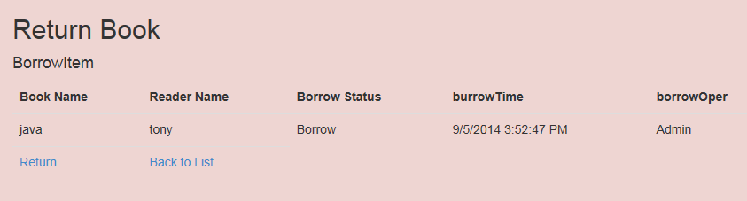

Chart 4-2

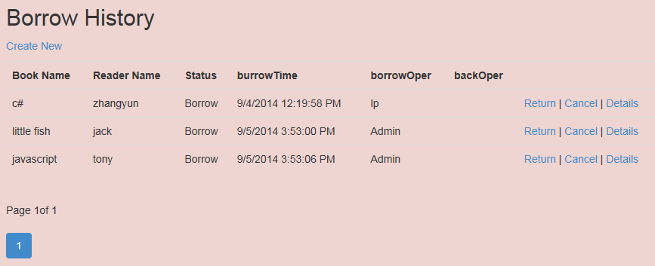

Chart 4-3

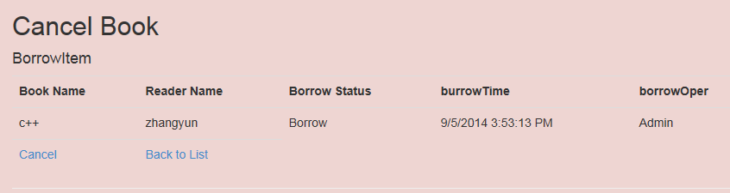

Chart 4-4

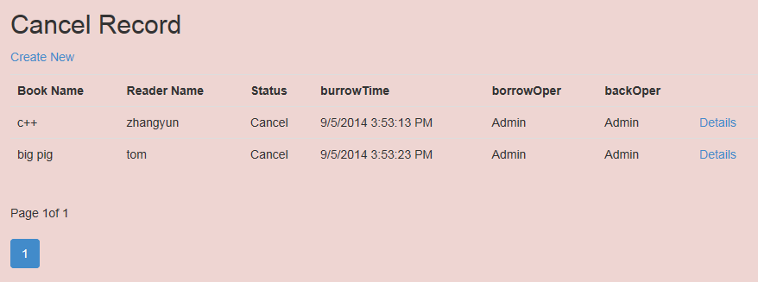

Chart 4-5

1. **Show details**

After add borrow record, you can through borrow records to find you borrowed book. You can use left return or cancel to change the book status. You can through different status to find these and through detail operation to show these details (Chart 4-6,4-7,4-8)

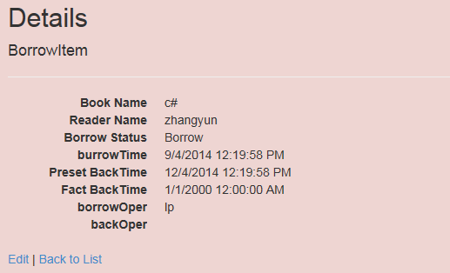

Chart 4-6

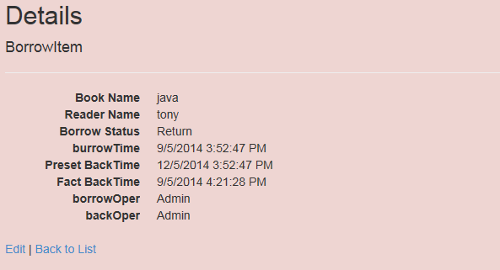

Chart 4-7

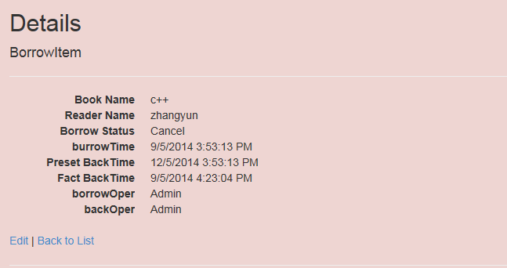

Chart 4-8

1. **Database**
   1. **Database tables**

### 2.1.1 tb_user(table1-5)

|  |  |  |  |  |
| --- | --- | --- | --- | --- |
| **Columns** | **Data type** | **Allow NULLs** | **Value/Range** | **Remarks** |
| **userId** | INT | Not allowed |  | Identity of each user |
| **userName** | nvarchar(MAX) | Not allowed |  | user Name |
| **Password** | nvarchar(20) | Not allowed |  | user password |

(table1-5)

### 2.1.2 tb_reader(table1-6)

|  |  |  |  |  |
| --- | --- | --- | --- | --- |
| **Columns** | **Data type** | **Allow NULLs** | **Value/Range** | **Remarks** |
| **readerId** | INT | Not allowed |  | Identity of each reader |
| **readerName** | nvarchar(MAX) | Not allowed |  | Reader Name |
| **phoneNum** | nvarchar(MAX) | allowed |  |  |
| **Gender** | INT | Not allowed |  |  |
| **email** | nvarchar(MAX) | allowed |  |  |
| **balance** | float | Not allowed |  |  |
| **enableBorrowNum** | INT | Not allowed |  |  |
| **createName** | nvarchar(MAX) | Not allowed |  |  |
| **createTime** | datetime | Not allowed |  |  |

(table1-6)

### 2.1.3 tb_book(table1-7)

|  |  |  |  |  |
| --- | --- | --- | --- | --- |
| **Columns** | **Data type** | **Allow NULLs** | **Value/Range** | **Remarks** |
| **bookId** | INT | Not allowed |  | Identity of each book |
| **bookName** | nvarchar(MAX) | Not allowed |  | Book Name |
| **author** | nvarchar(MAX) | allowed |  |  |
| **publish** | nvarchar(MAX) | allowed |  |  |
| **type** | nvarchar(MAX) | Not allowed |  |  |
| **amount** | INT | Not allowed |  |  |
| **currAmount** | INT | Not allowed |  |  |
| **addName** | nvarchar(MAX) | Not allowed |  |  |
| **addTime** | datetime | Not allowed |  |  |
| **imageURL** | nvarchar(MAX) | allowed |  |  |
| **introduction** | nvarchar(MAX) | allowed |  |  |

(table1-7)

### 2.1.4 tb_borrowItem(table1-8,-9)

|  |  |  |  |  |
| --- | --- | --- | --- | --- |
| **Columns** | **Data type** | **Allow NULLs** | **Value/Range** | **Remarks** |
| **borrowId** | INT | Not allowed |  | Identity of each borrow item |
| **status** | INT | Not allowed |  | Reader Name |
| **borrowOper** | nvarchar(MAX) | allowed |  |  |
| **backOper** | nvarchar(MAX) | allowed |  |  |
| **burrowTime** | datetime | Not allowed |  |  |
| **ygBackTime** | datetime | Not allowed |  |  |
| **sjBackTime** | datetime | Not allowed |  |  |
| **bookId** | INT | Not allowed |  |  |
| **readerId** | INT | Not allowed |  |  |

|  |  |  |
| --- | --- | --- |
| **Foreign keys** | **Child** | **Parent** |
| FK_dbo.tb_borrowItem_dbo.tb_book_bookId | **bookId** | tb_book.bookId |
| FK_dbo.tb_borrowItem_dbo.tb_reader_readerId | **readerId** | tb_reader.readerId |

(table1-8)

(table1-9)

* 1. **Entity Relationship (chart2-1)**

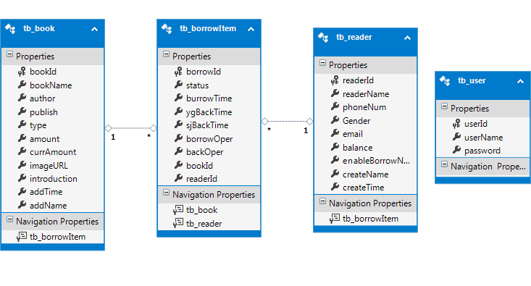

Chart2-1